加纳/ACC

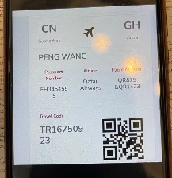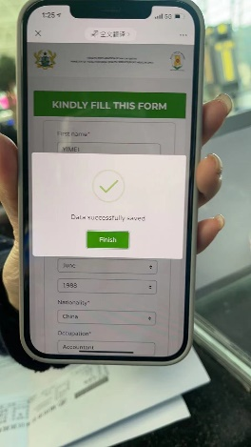
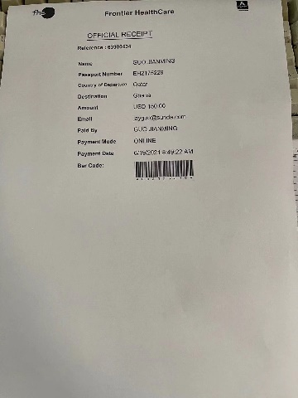

尼日利亚/LOS、ABV
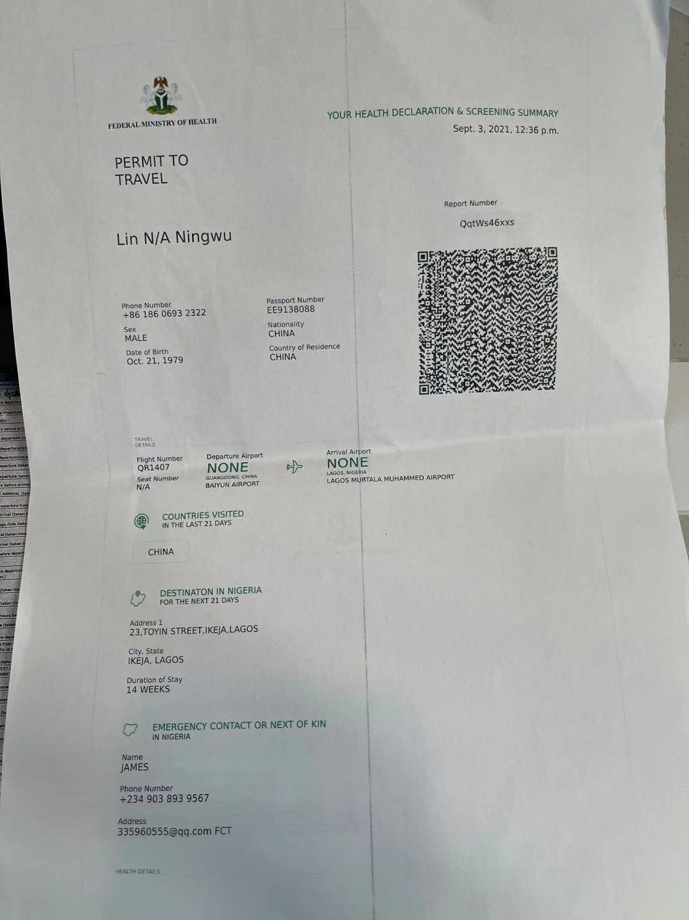

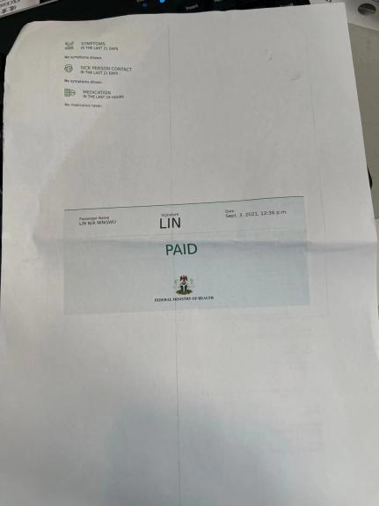

科特迪瓦/ABJ:HTTPS://DEPLACEMENT-AERIEN.GOUV.CI
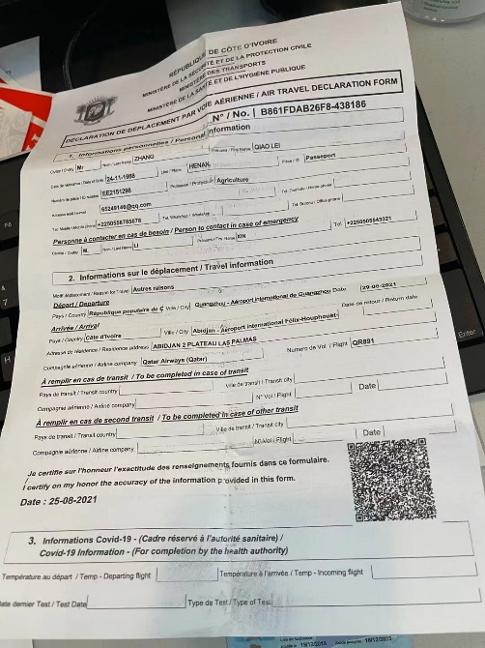

约旦/AMM:PAYMENT 28JOD ON HTTPS://WWW.VISITJORDAN.GOV.JO

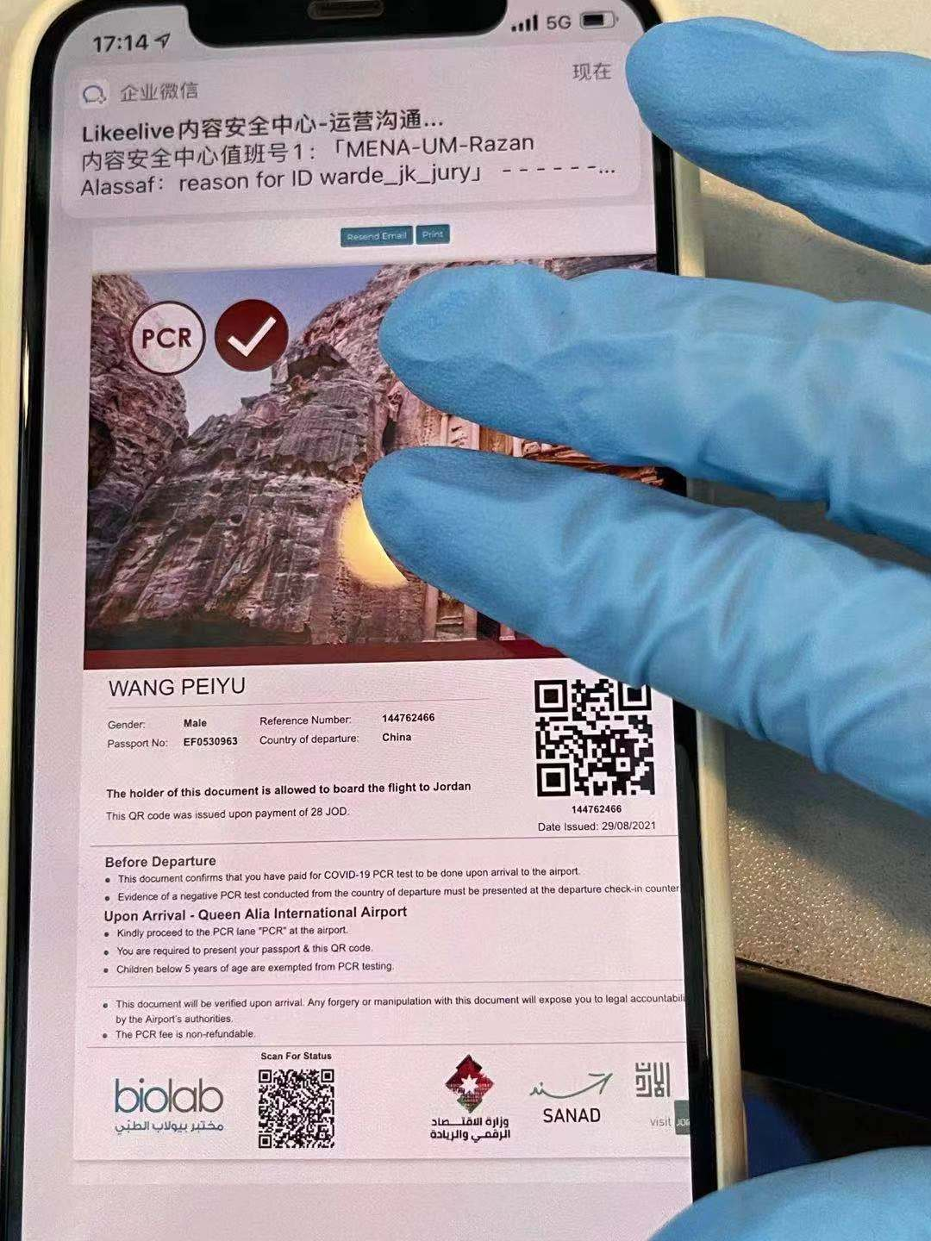

西班牙/MAD、BCN:HTTPS://WWW.SPTH.GOB.ES

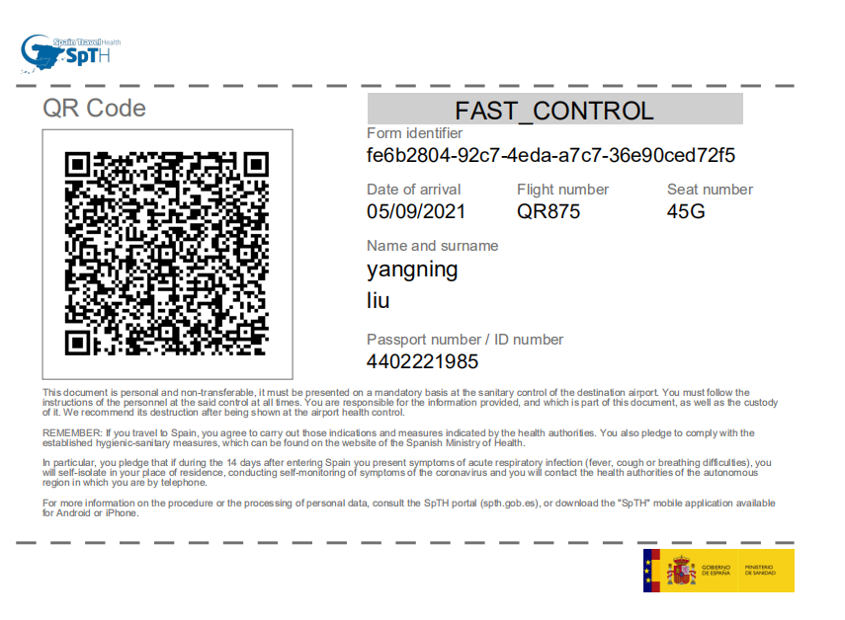

沙特/DMM、JED、RUH:fill a form at check-in counter/DOWNLOAD THE TAWAKKALNA APP

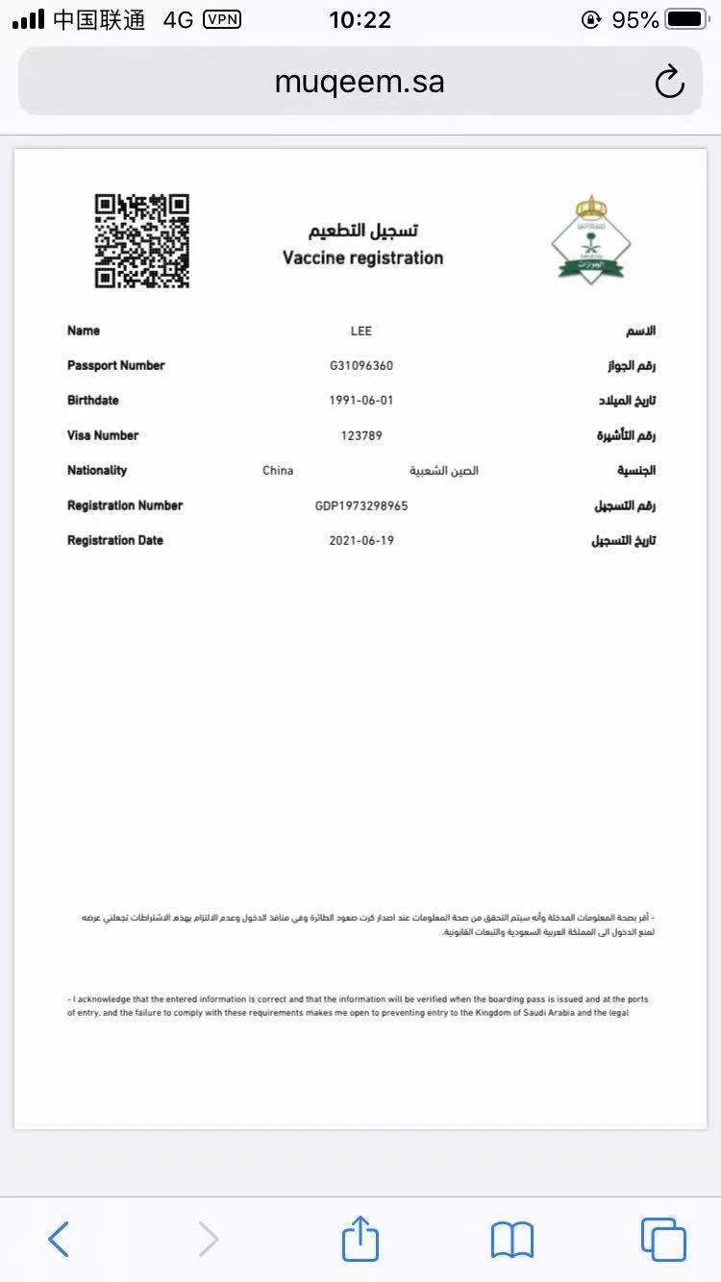

巴西/GRU:HTTPS://FORMULARIO.ANVISA.GOV.BR/
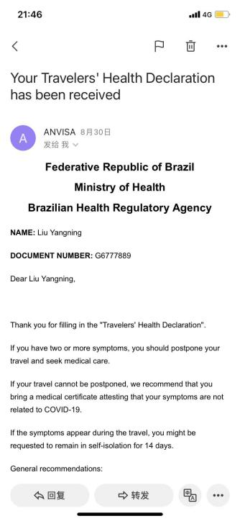

尼泊尔/KTM:PRINTED "INTERNATIONAL TRAVELLER FORM" MUST BE PRESENTED AT CHECK-IN via HTTPS://CCMC.GOV.NP/ .
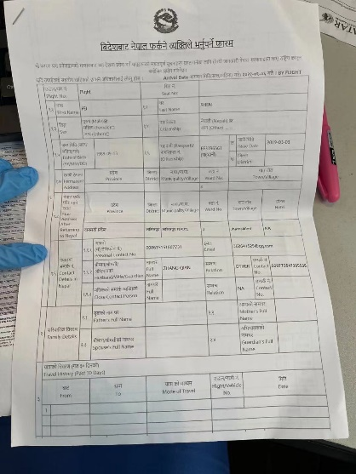

卢旺达/KGL:HTTPS://TRAVEL.RBC.GOV.RW/
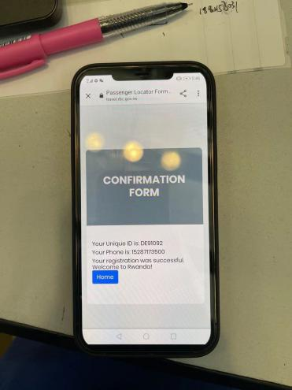

安哥拉/LAD:HTTPS://WWW.COVID19.GOV.AO/
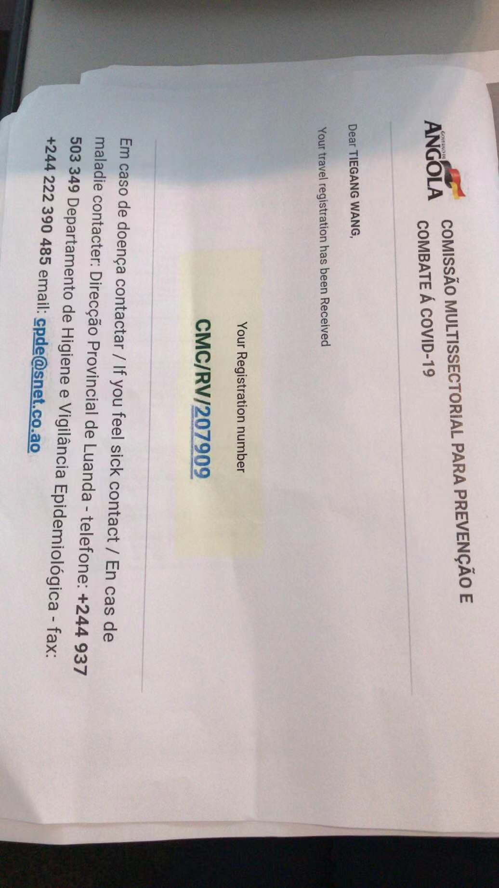

英国/LHR:HTTPS://WWW.GOV.UK/PROVIDE-JOURNEY-CONTACT-DETAILS-BEFORE-TRAVEL-UK
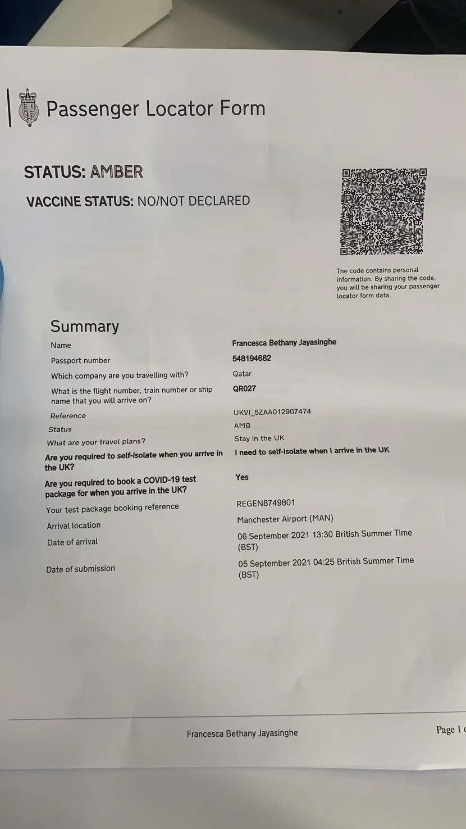

塞浦路斯/LCA：HTTPS://WWW.CYPRUSFLIGHTPASS.GOV.CY

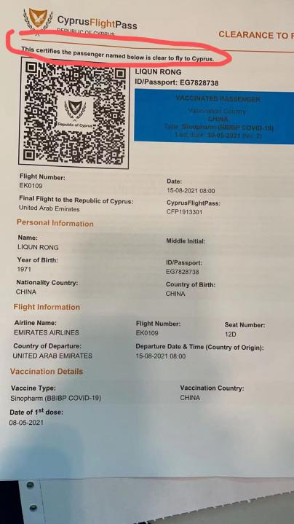

阿曼/MCT: HTTPS://COVID19.EMUSHRIF.OM
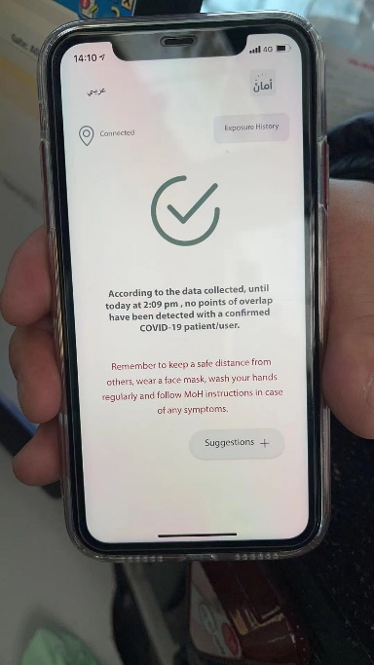

意大利/MXP:HTTPS://APP.EUPLF.EU/
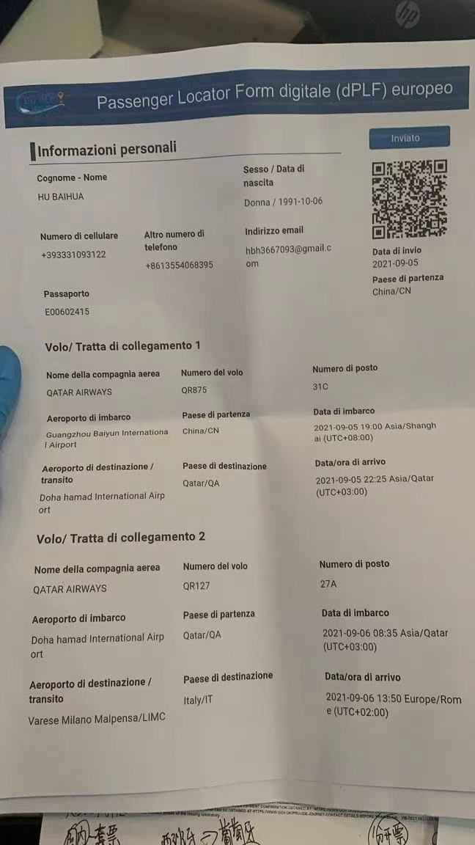

肯尼亚/NBO: HTTPS://EARS.HEALTH.GO.KE/AIRLINE_REGISTRATION/
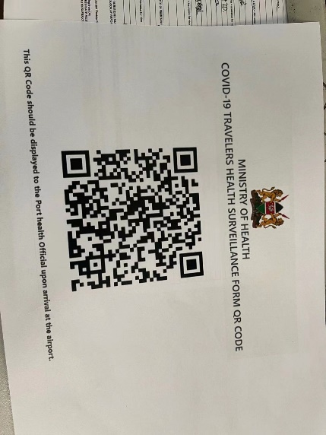

土耳其/SAW:HTTPS://REGISTER.HEALTH.GOV.TR
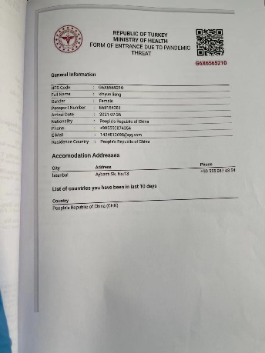

印度/CCU: WWW.NEWDELHIAIRPORT.IN
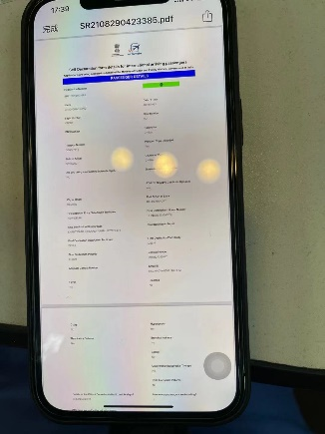

LHE: HTTPS://PASSTRACK.NITB.GOV.PK/
